1. **Component Diagram**

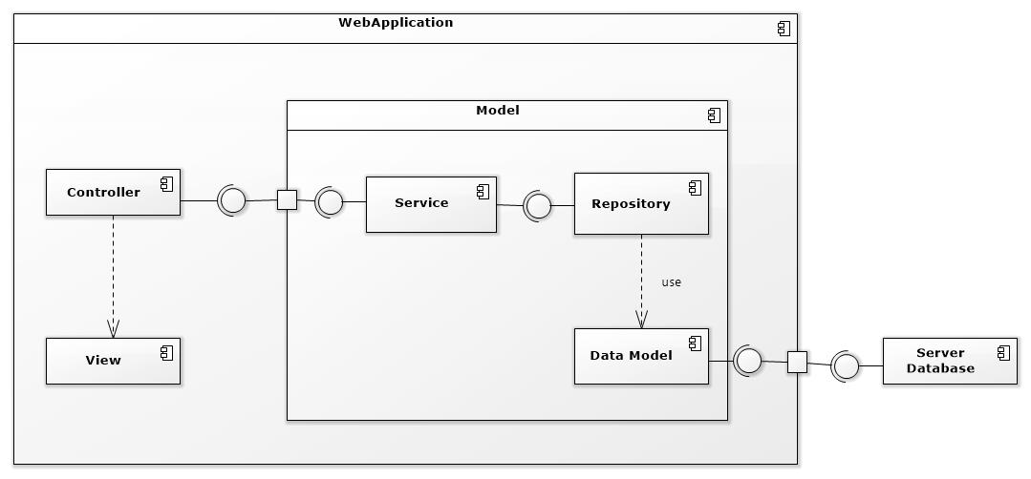

Figure 1: Component Web Diagram

| **Components Dictionary: Describes components** | |
| --- | --- |
| Web Apllicaiton | Component to controll the system and process request from mobile. Contains sub component: Model, Web Service, Controller. |
| View | Component that display data |
| Controller | Component of website to handle request from web |
| Service | Component to handle business logic of Website component |
| Repository | Component that communicate with database |
| Data Model | Component that do the interaction between the system and database. Contain sub components: Repository and Service |
| Server Database | Component that store data of system |

Table 1- Components Web Dictionary

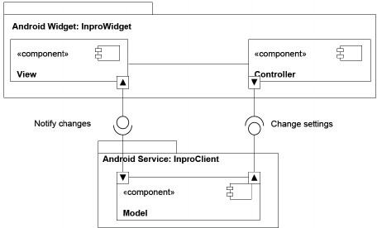

Figure 2: Component Android Application Diagram

| **Components Dictionary: Describes components** | |
| --- | --- |
| Android Apllicaiton | Component to controll the system and process request from mobile. Contains sub component: Model, Android Service, Controller. |
| View | Component that display data. |
| Controller | Component of application to handle request from application. |
| Android Service | Component to handle business logic of application component. |
| Model | Component that do the interaction between the system and database. Contain sub components: Repository and Service |

Table 2- Components Application Dictionary